**Önálló laboratórium**First steps: Getting started with Matlab, Simulink by creating a model

For the parameters a real car model was chosen (Tesla Model S)

* Make a datasheet with the required parameters

Model type:

* Two inputs:
  + Current speed v(n)
  + Current torque on wheel M(n)
* One output: Speed in the next step

Operation of the model:

* Basic force equations were given
* Invested force can be calculated by the torque
* The difference will accelerate/slow the vehicle

Used operators in Simulink:

* Discrete delay
* Gain
* Sum
* Scope

Results: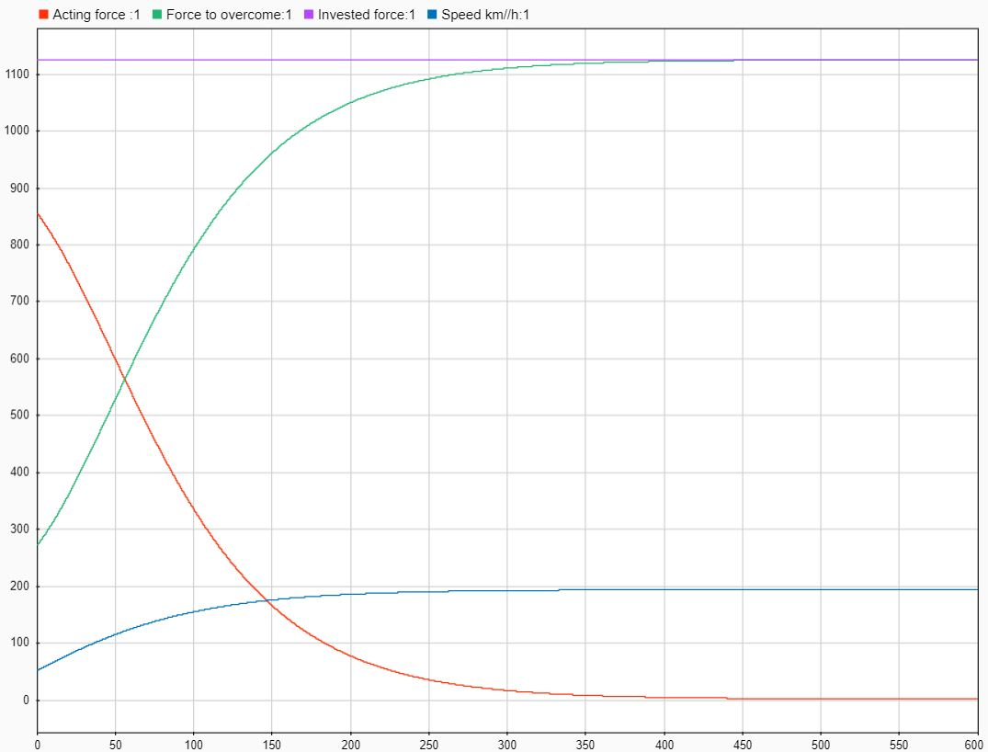

Remark:

The initial speed value is 50km/h and the torque is 300Nm. It can be seen that the car is accelerating until it reaches the maximum speed for the given torque.

I learned the basic use of the software. The model is finally working well, so we can continue our research.